**Definition: Create a wireframe and apply prototyping to it.**

**Solution:**

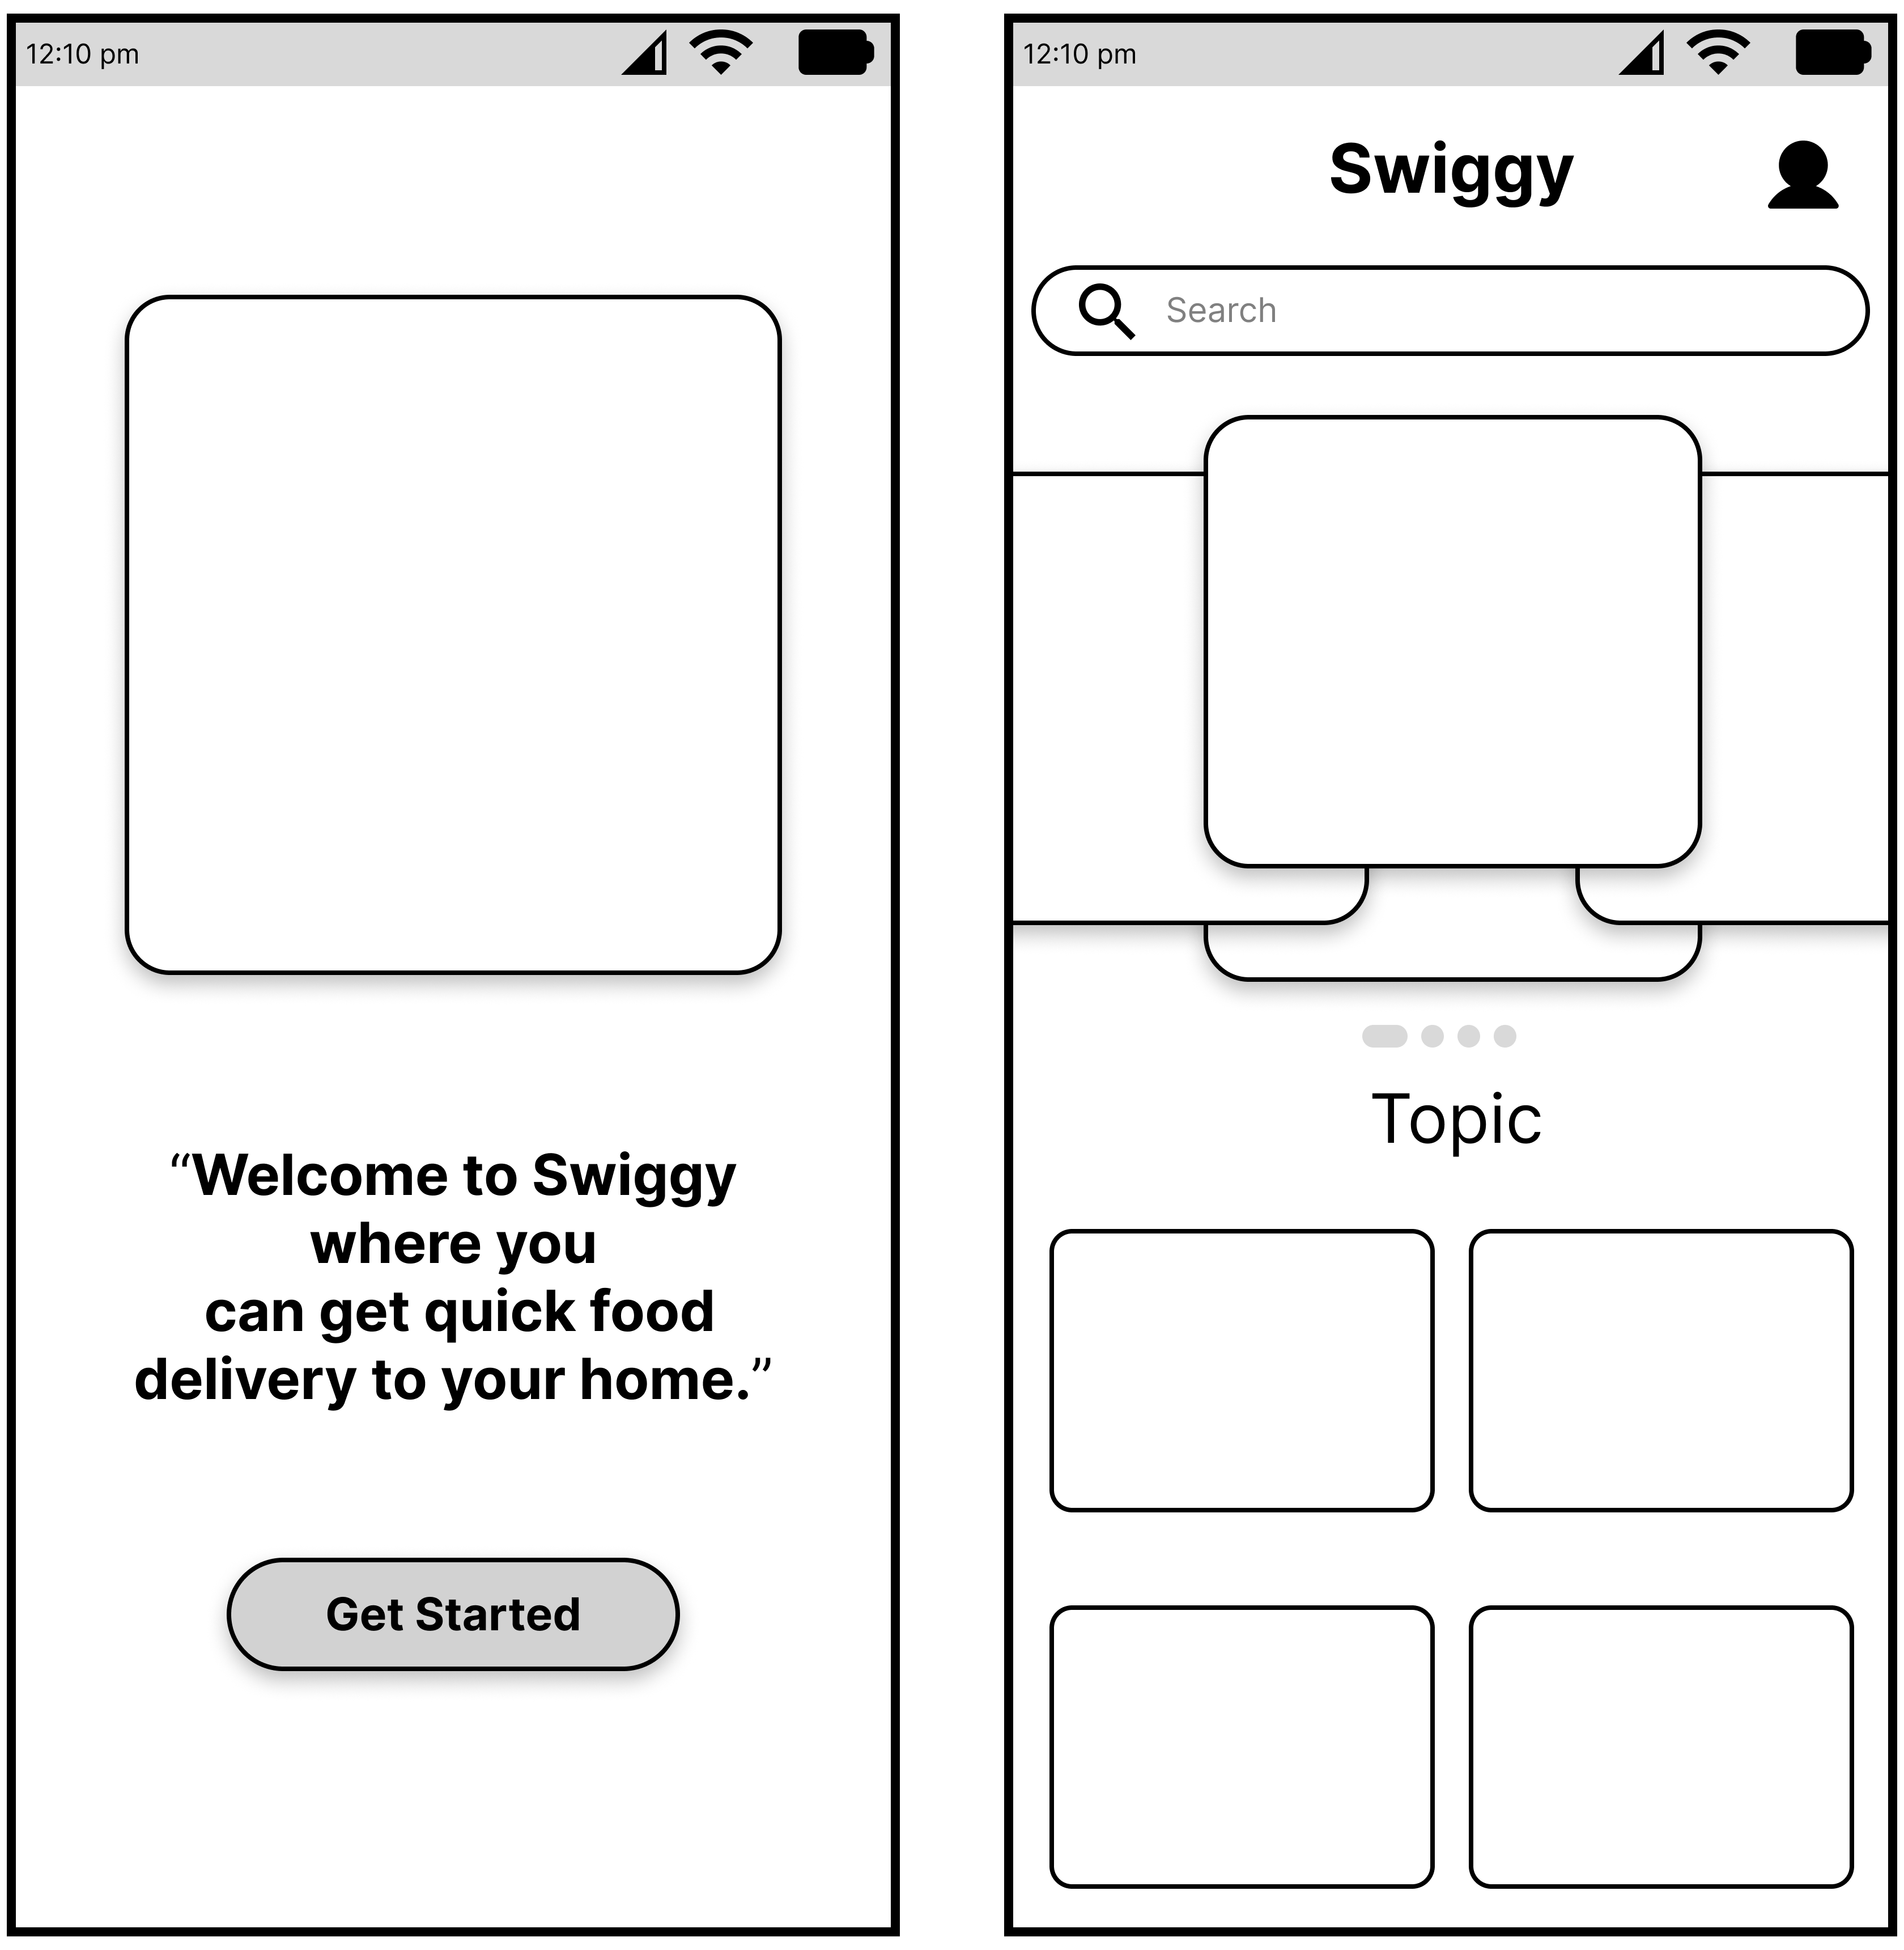

**Steps:**

* First Open Figma in browser mode.
* Then create the new document **File à New Figma Design.**
* **SCREEN-1:**
  + Now add one frame of **iPhone 14** on your canvas give color=”**#FFFFFF”**.
  + Take rectangle of width**=”390 px”** and **height=”30 px”**, add Text using text tool and write “**12:10 pm**” on the left side of rectangle.
  + User Iconify to place **“Battery icon”, “Wi-Fi icon”** and **“Network icon”** on the right side of rectangle
* Now, Go to the **Export** button in the property panel. And **Export** it with .**JPG/.PNG** format.